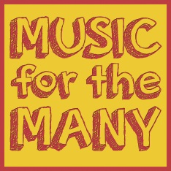
Music for the Many
News
Newsletter 1 June 2018
email: music4themany@gmail.com or visit our Facebook page.
Welcome to the very first Music for the Many newsletter! Our aim is to bring equal opportunities back into music education by offering all our children a chance to learn an instrument, in school, for free.
We have had an incredible start to this new project, with so much public support and enthusiasm, not just from the people of Todmorden, but from people all over the country, who recognise the need for what we are doing and have donated funds and all sorts of musical instruments for our children to take home and learn. Now, thanks to this generosity, 33 children at St. Joseph’s are learning to play musical instruments and 28 are just starting at Ferney Lee.
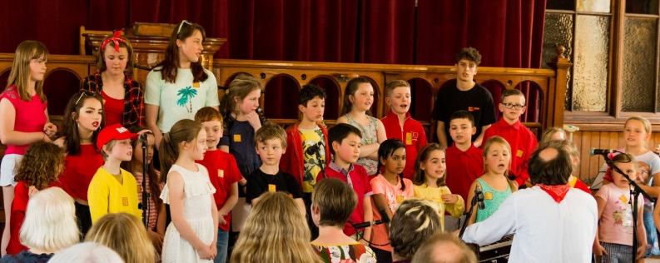
We had a fantastic turnout for our M4M Choir, with 25 children from Cornholme, Ferney Lee, National, St. Joseph’s and Tod High School joining us to sing at Todmorden Folk Festival. Thanks to parents and teachers for supporting this. Here’s what one visitor said about our performance: “This was inspiring and emphasised inclusivity, the joy of enthusiasm and the sheer power of making music together. Brilliant.”

We’ve had superb fundraising concerts at the Fielden Centre from The Daniel Bath Trio, The Geoff Atherton Quintet and The Black Sheikhs – and the next one will be given by The Orion Chamber Choir on 22nd July. These gigs are a chance to support the charity and to experience some great live music by inspirational performers. There’s always a bar serving drinks and Angela’s legendary homemade cakes.
A massive thank you to the Scouts’ and Guides’ Gang Show! Music for the Many was their chosen charity for their amazing 2018 show. You’re never too young or too old to sing and shake a bucket for your favourite musical charity.
...and we’re very excited to announce that, having been inspired by our beautiful choir’s performance, Hebden Bridge W.I. have chosen M4M as their charity for 2018/2019. Make sure you buy lots of their cakes! Thank you, women of Hebden Bridge!
How you can help us
Until quite recently it was normal for children in school to learn a musical instrument for free and many of today’s professional musicians, including M4M’s tutors, owe their careers to having this free and equal opportunity as children. Today, fewer and fewer children in state schools are receiving tuition, and amazing talent is not given the chance to develop. We want to give every child a chance to discover their own gift for music-making through professional instrumental tuition with no charge, and nurture the musicians of the future.
We are a charity, and receive no funds other than the money from donations and grants. A paired or individual 20 minute lesson costs £10 to provide. Money that we raise goes to pay the tutors and occasional expenses such as instrument purchase or repair.
We know that schools and families want to support us in whatever way they can, and to help this incredible project put down strong roots for the future and lead the way in music education for the rest of the country.
If you would like to help us you can.....
- like us on Facebook and share our posts. Spread the word to grandparents, aunties, uncles and friends.
- Come along to our fundraising events – or organise your own!
- Give money – by cheque, standing order or through our charity fundraising page: www.JustGiving.com/musicforthemany. Forms and cheques (payable to Music for the Many) can be returned to the school office. Standing order (even just £1 per month) is the most effective way to give, as it gives us a secure and predictable income. You can cancel or change your order at any time. If you choose to give money, this is always to support all our teaching, not to pay for your child’s lesson. Lessons are, and always will be, free.
- Donate unwanted musical instruments, even if they’re not in perfect condition.
- Get in touch if you would like to help us with practical tasks such as helping at events or fundraising.

To get in touch with us, email music4themany@gmail.com , or contact us on Facebook.
Thank you for your support.

