Music for the Many
News
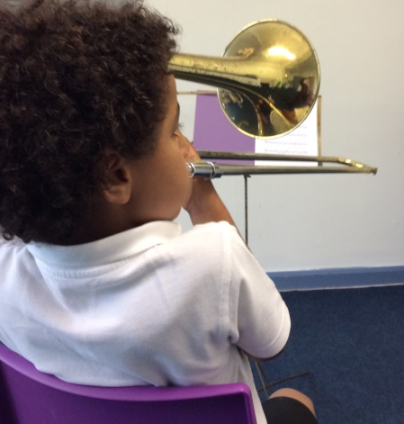

Newsletter 2 November 2018
email: music4themany@gmail.com or visit our Facebook page.
Our aim is to bring equal opportunities back into music education by offering all our children a chance to learn an instrument, in school, for free.
Thank you very, very, very much!
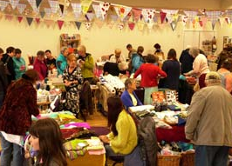
We’re half way through another busy term with Music for the Many, and there are lots of exciting opportunities coming up to get involved with our work. But first we need to say a massive thank you to all of you for your amazing support. Thank you for your donations, your standing orders and your gifts of musical instruments. Thank you for following our Facebook page and sharing our posts, and, especially, coming to our events. Thank you, parents and carers, for supporting the children at home with their music practice, and helping them to take good care of their precious musical instruments and to bring them back for each lesson. The children are loving their music lessons, and making amazing progress. We’re hoping to put some clips of children’s practise on our website and Facebook page, so if you can get a video of your child practising, send it to us and we’ll put up as many as we can. We’re so proud of them!

A special thank you this year to Hebden Bridge Women’s Institute, who have chosen Music for the Many to support with their fundraising this year. Their first event was the ever- popular Hebden Bridge Rag Market, which was a cornucopia of crafty delights. More W.I. fundraising is to come, so keep an eye on our Facebook page to find out what’s going on.

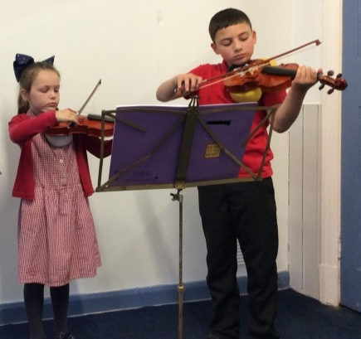
Another huge thank you is due to our brand new tutor. Helen Thatcher is a well-known professional ‘cellist and very experienced teacher. She approached us after reading about the project in the ScallyMag, and offered to teach for us! We are very privileged to have her on board, and she has joined the crew teaching at Ferney Lee. We have been busy acquiring ‘cellos for the children to learn with, so thank you to several generous donors who have given us instruments; others have been bought second-hand, and the Music Cellar in Preston, kindly donated an instrument.
We now have children learning piano, violin, ‘cello, guitar, flute, recorder, tabla, trombone and trumpet, with 60 children currently learning in total. New starters (Year 3 children, and older children who would like to learn) will be able to start lessons in January. We would love to reach more children, and the more support we get, the more we can achieve.

The M4M choir is back!
We have some very exciting events coming up soon, so get your diaries out. By popular demand, the Music for the Many choir is back for another performance! We have been asked to sing at Todmorden Book Festival, on the 24th November, in the free family-friendly closing event at the Town Hall.
This choir is open to all children and young people, whether or not they have lessons with Music for the Many, or have sung with us before. No auditions; everyone is welcome. If you know anyone who would like to be involved, just get in touch using the details at the top of the page, or turn up at our first rehearsal, with a parent or carer who can fill in a consent form. Rehearsals will be on the 9th, 13th and 16th of November, 4-5 pm at Todmorden Central Methodists’ Church.
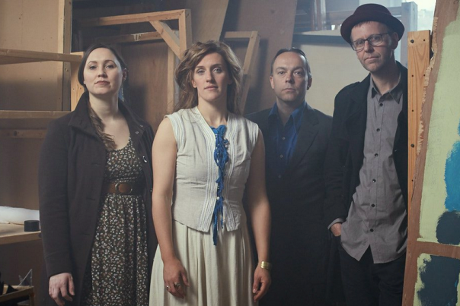
We also have a fabulous fundraising concert this month at the Fielden Centre. ‘The Greyhounds’ are bringing us their haunting and beautiful songs, some traditional and some new, for a very special evening on the 18th November, at 7 pm. The famous Music for the Many bar will also be available, of course, with wine, soft drinks and home-made cakes. You can reserve your tickets in advance from Music for the Many, or you can buy them on the door.

If you feel that the opportunity to learn a musical instrument is important to your child, please consider making a donation to help us reach more children in Todmorden and beyond. Giving us as little as £1 or £2 a month through standing order helps us to maintain a steady and reliable income. We receive no funding from the school or the government to teach; we rely on gifts from generous people who recognise the importance of the work we do.
If you feel you can help, please contact Music for the Many or ask at your school office for a standing order form.
If you can’t help us with money right now, you can always help by following our Facebook page, sharing our posts, especially our events, and telling people about what we do.
We hope you are as proud as we are to be a part of the extraordinary Music for the Many community.

Diary Dates:
Choir rehearsals: 9th, 13th, 16th November. (4pm at the Central Methodist Church)
‘The Greyhounds’ fundraising concert: 18th November (7pm at the Fielden Centre)
Choir performance at the Todmorden Book Festival: 24th November (Event from 2pm at Todmorden Town Hall)

